****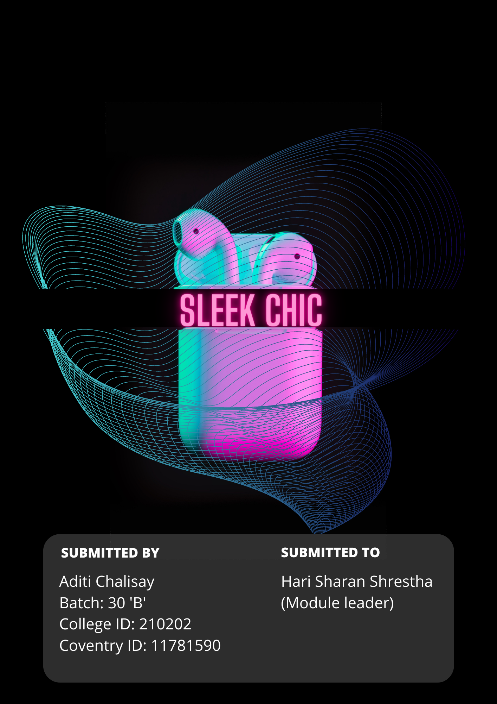

Git repo link: <https://github.com/aditi002/SleekChic_djangoproject.git>

Video link: <https://youtu.be/XrEI17LekCk>

# ABSTRACT

Sleek chic is an e-commerce site focused on providing the user with sophisticated elegant accessories for their devices that live up to one’s chic and stylish personality. Aiming for customer satisfaction and providing genuine and quality products, this project also provides safety of data of customers.

TABLE OF CONTENT

INTRODUCTION 5

FEATURE OF THE SYSTEM 6

AIM 6

OBJECTIVES 6

SCOPE 7

WHAT I LEARNT 7

USE CASE DIAGRAM 7

RICH PICTURE: 8

ERD-DIAGRAM 9

FROTEND 10

TECHNOLOGIES: 10

HTML (Hypertext Markup Language): 10

CSS (Cascading Style Sheet): 10

JS (JavaScript): 10

React JS: 10

Bootsrap: 11

IMPORTANCE OF RESPONSIVE DESIGN 11

RESPONSIVE CHECK 12

DATABASES 12

INTRODUCTION: 12

ADVANTAGES AND DISADVANTAGES OF MYSQL: 14

BACKEND 14

INTRODUCTION 14

ADVANTAGES AND DISADVANTAGES OF DJANGO 17

SCREENSHOTS OF BACKEND 18

ADMIN: 18

TESTING: 19

PROJECT ISSUES 20

ISSUES DURING THE PROJECT DEVELOPMENT 20

FUTURE WORK 20

CONCLUSION: 21

REFERENCES: 21

# TABLE OF FIGURES

Figure 1 Use Case Diagram 8

Figure 2 Rich Picture 8

Figure 3 ERD DIAGRAM 9

Figure 4 frontend 11

Figure 5 Responsive 12

Figure 6 Database 13

Figure 7 MVT pattern in django 15

Figure 8 MVT pattern of sleek chic 16

Figure 9 Backend 18

Figure 10 Django admin 19

Figure 11 Testing 19

# INTRODUCTION

Determined to provide an easy online shopping experience with fast and efficient service, Sleek chic offers users with best and most original quality products as it believes in customer satisfaction. An e-commerce site where users can search for required products with instant delivery making it hassle-free and less time-consuming. Sleek chic has an easy user interface and a simple yet modish site design. Sleek chic is an e-commerce site focused and prioritized on providing user/customer with sophisticated yet simple elegant electronic accessroies that lives up to one’s expectation and chic personality. Aiming for customer’s satisfraction and bringing the most genuine and quality products. Believing in privacy of one’s data and providing security this project delivers safety for data privavcy and security.

Sleek chic is a store management project. This project uses MySQL as database where all the required tables are created inorder to store data of user/customer. Every details of products such as item in stock, product ordered by customer, are stored in database. The interface of this project sleek chic is made easier so that user/customer shall face no difficulties while operating the system. The frontend of this project is built by using HTML, CSS and JavaScript whereas for backend I used django. Since this system is user-friendly, anyone can use or operate this system without having to face any difficulties. The frontend of this project is built by using HTML, CSS and JavaScript whereas for backend I used django. Since this system is user-friendly, anyone can use or operate this system without having to face any difficulties. Sign up and log in system is provided by the system so that our users can log in into the system to shop from this e-commerce site.

The user / customer can even search up the desired item available in the system by filling up the name of the product in search field given in the navigation bar.

To make things easier for the user, this system has category options, where user can ddirectly view desired product by choosing the category of the product. This makes the system easier to use. Sleek chic also provides add to cart and buy now options for user. The products in the cart can be added more as well as removed as per customer’s need. Not only in cart but user/ customer are also provided with option to edit their profile if required.

## FEATURE OF THE SYSTEM

As mentioned int the above, Sleek chic is a project that provides user with various necessary features and functions:

* Provides user a sign up as well as log inn page to sign in the system. User should fill up the forms given by the system inorder to place an order of choosen item.
* Search bar is given in the navigation bar, so that its easier for user/ customer to search up products.
* Category of the products are differentitated accordingnly for hastle-free search.
* In order to place an order, customer are provided with add to cart ot buy now options right below the products he/she is viewing.
* Price of the products are displayed as well as user can whistlist the product they are willing to buy later on.
* Message is given to the customer after they place an order for the confirmation.
* Payment form is and placing order forns are also provided to the user ti fill up required information and details.
* Review form is also provided below the product details where user/ Customer can write review of the product they bought and also provide ratigs of a product from 1 to 0.
* Logout feature offers user/ customer to log out from the system.
* Admin can add products, view orders of a customer, view cart, and many more from django admin as well.

## AIM

Sleek-chic mostly focuses on the quality of products offered to a customer as well as user’s satisfraction from this store management system.

## OBJECTIVES

The objective behind this project is listed below:

* Provide the best original and quality product so that our customer don’t face counterfeit products.
* Best user experience and satisfaction from this e-commerce site.
* Make online shopping experience/e-commerce site shopping efficient and hastle-free.
* Reduce the chance that our customer face scams due to counterfeit products.
* Deliver a user-friendly interface where one doesn’t require much effort to learn to operate the the system.

SCOPE  
Below given are the scope of this system:

* Eliminates fraudulent and scamming products from a customer.
* Time-saving and instant service with genuine products.

## WHAT I LEARNT

Learing is an never ending process. Having to built a project on your own has a lots of learning in it itself. I have worked on this project’s frontend by using HTML, CSS and JavaScript. These three is key ingredients to make frontend look decorative, responsive, effective and interactive. There were many things to learn from HTML such as how containers, divs, header, footer and text, text-field, buttons are entered in order to make a website. Where as CSS holdsimportant role in decorating these items mentioned in HTML. The styling, sizing, adjusting, are all part of CSS. Without HTML as a blueprint, CSS doesnot exist to polish the dinal picture. Same for JavaScript which is used in this project to make frontend more interactive to user. Like HTML and CSS, JavaScript is also an text-based programming language. Although I feel like there is much more for me to explore these HTML, CSS and JavaScript than I have researched and workrd on it to build this project.

Learning django as backend and MySQL as database was also not easy job. Unlike MySQL, I had never worked on django project before. Learning period was short yet enough for me to build a e-commerce site within a few months. Personally, I feel like django has many add ons. The URL mappings and changes in view.py, models.py, settings.py can be really frustating sometimes. The paths are to be specific and its harder to handle exceptions one after another. But there was much more to learn in django project too such as working with django admin, django database, file uploads, static files handling and many more. At last building this e-commerce site was all learning process for me.

# USE CASE DIAGRAM

A use case diagram in the Unified Modeling Language (UML) can condense the specifics of your system's users (sometimes referred to as actors) and their interactions with the system. You'll need a specific set of connectors and symbols to construct one.

The use case diagram of Sleek chic is shown below:

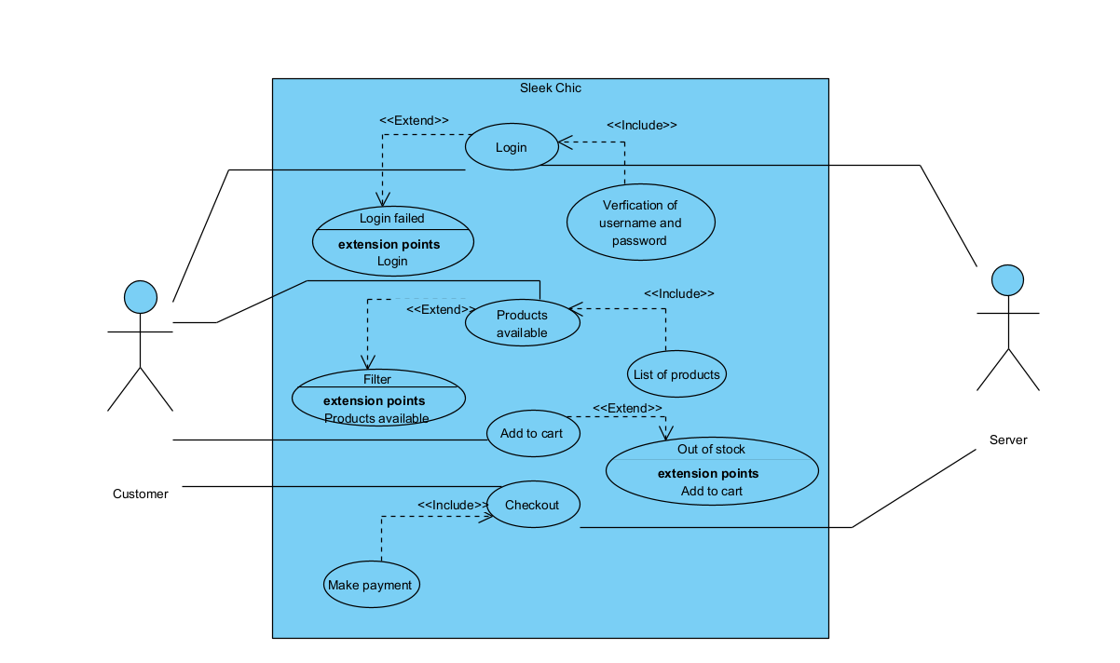

Figure 1 Use Case Diagram

# RICH PICTURE:

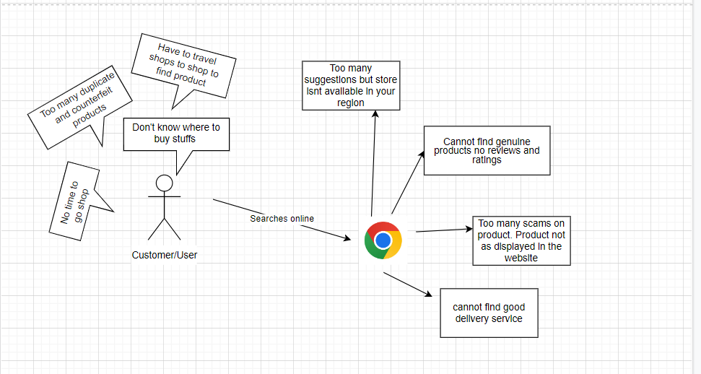

Figure 2 Rich Picture

## ERD-DIAGRAM

Entity Relationship Diagram, or ER Diagram for short, is a diagram that shows the relationships between entity sets that are stored in a database. To put it another way, ER diagrams assist in describing the logical organization of databases. Entities, attributes, and relationships are the three fundamental ideas that serve as the foundation for ER diagrams.

Rectangles are used to represent entities in ER Diagrams, ovals are used to indicate attributes, and diamond shapes are used to represent relationships.

An ER diagram and a flowchart initially have a similar appearance. However, ER Diagram is a distinctive model because of the numerous specific symbols and their meanings. The entity framework architecture is represented by the ER Diagram.

The erd-diagram of this system is given below:

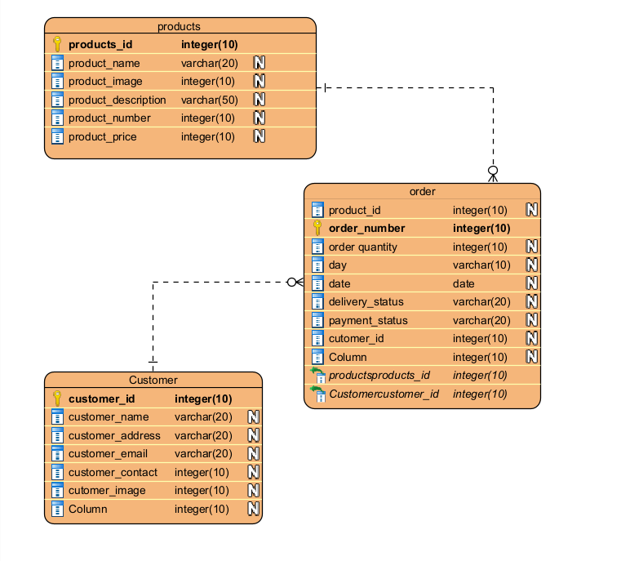

Figure 3 ERD DIAGRAM

# FROTEND

## TECHNOLOGIES:

The technologies I have used in building a frontend in this project is given below:

(Knieć, 2022)

* HTML (Hypertext Markup Language)
* CSS (Cascading Style Sheet)
* JS (JavaScripts)
* ReactJs
* Bootstrap

### HTML (Hypertext Markup Language):

HTML is the core frontend development fundamental in this project. HTML elements has provided in adding header, footer, containers, texts, text-fields, buttons, and much more in order to develop a fronrend for this project.

### CSS (Cascading Style Sheet):

CSS is another core frontend development fundamental in this project. It helped in creating more styling in addition to the structure created by the help of HTML. CSS has made my project responsive, more interactive and eye-catching to viewers too.

### JS (JavaScript):

Like other text-language programming language used in frontend development (HTML and CSS), JavaScript is also one of the most important frontend technology used in making this project. JavaScript has helped me in adding shopping cart to my e-commerce website .

### React JS:

Well-known for frontend JavaScript library, ReactJS has also been accepted as a wonderful library in the frontend family used for creating a user interface. React JS also makes ise of MVC ( Model View Control) architecture.

### Bootsrap:

Bootstrap is a powerful front-end framework used to develop contemporary websites and online apps. Despite having a ton of HTML and CSS templates for UI interface components like buttons and forms, it is open-source and free to use. JavaScript extensions are supported by Bootstrap as well.

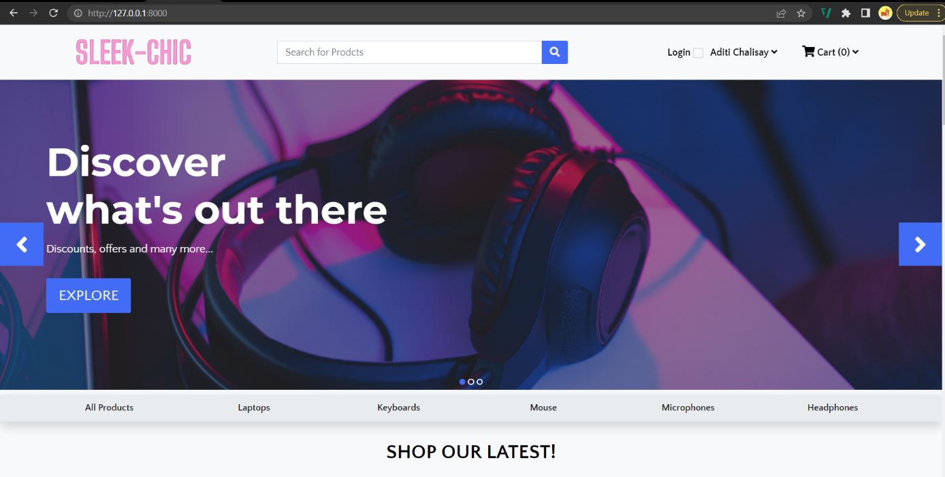

Figure 4 frontend

## IMPORTANCE OF RESPONSIVE DESIGN

Responsive design makes your web page appear equally good on all the shapes and sizes of device. Sizing is really important as website can be used on desktops of any size and mobile phones of any kinds. Responsive designs holds integrity of the website as well as makes the web page more user-friendly. ("How Important Is Responsive Design?", 2021)

Responsive design of web page simply means to develop responsive website that fits on every screen a user is using web page on. Such as desktop, tablets, and mobile phone of any kind. By making wesite respinsive, it helps in user interaction. The user doesnot have to face the situation where they have to view the screen horizontally, pinch or zoom out in the screen to view the hidden content.

Sleek chic is an responsive designed e-commerce website. That allows the user to view the web page on any kinds of screen they are viewing on.

## RESPONSIVE CHECK

This system has responsive design where viewers can view this website on any devices. The viewers don’t have to face difficulties zooming in and out for the hidden content in the website. Responsive design has made Sleek chic less time consuming, save loading time and working on different devices very effectively. Below screenshots shows responsive design in the website system of Sleek chic.

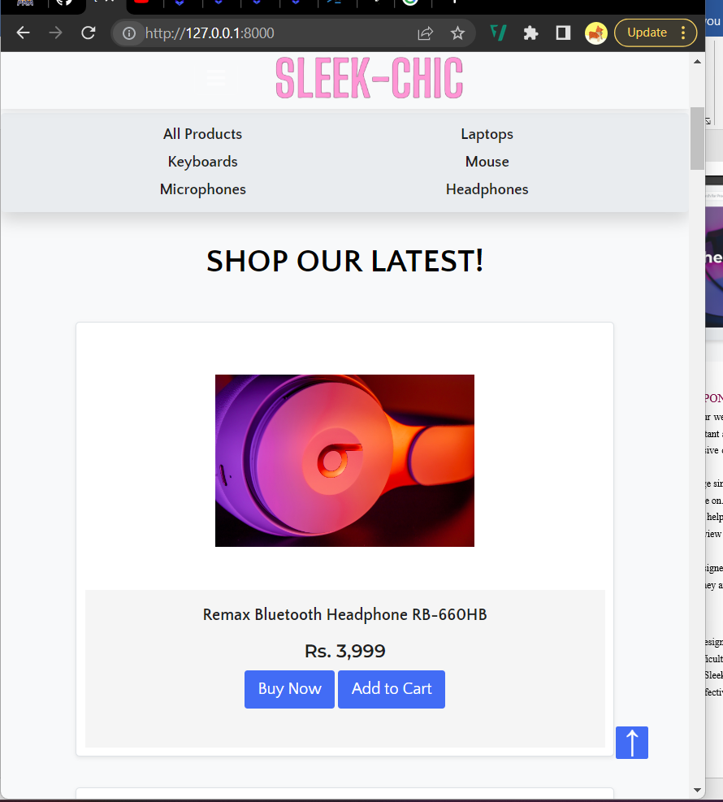

Figure 5 Responsive

# DATABASES

## INTRODUCTION:

Database can be anything from shopping list to big coporate networks. In order to access such data, ass or process, we need a amanagement system that stores such data in computer database. In this project I have used most popular Open Source SQL database management system, supported by Oracle Coporation, MySQL database server. Though computer devices can handle larger datas, database management system such as MySQL can help in central role of managing and computing larger datas.

MySQL is an relational database system which means it stores data in different tables accordinly rather than storing all data at one room. This databse enforces rules that is set up for relations between different data fields, such as ont-to-one, one-to-many, required or optional, so that, the databse is well- designed. Such well-designed databse avoids inconsistence, duplicate, orphan, out of date, or missing data. ("MySQL Advantages and Disadvantages - techstrikers.com", 2022)

MySQL is an open source database server which means yoou can download this software from internet and modify it to anything that suits your need. Even if you delicate an entire machine to MySQL, you can take all advantages of CPU power, and I/O capacity by adjusting the setting. It can handle databases much faster and is highly used to access database on the internet.

MySQL database has helped in this project Sleek chic by supporting backends, client programs, libraries and administrative tool, creating tables to store data accordingly, store data of product, shopping cart and many more.

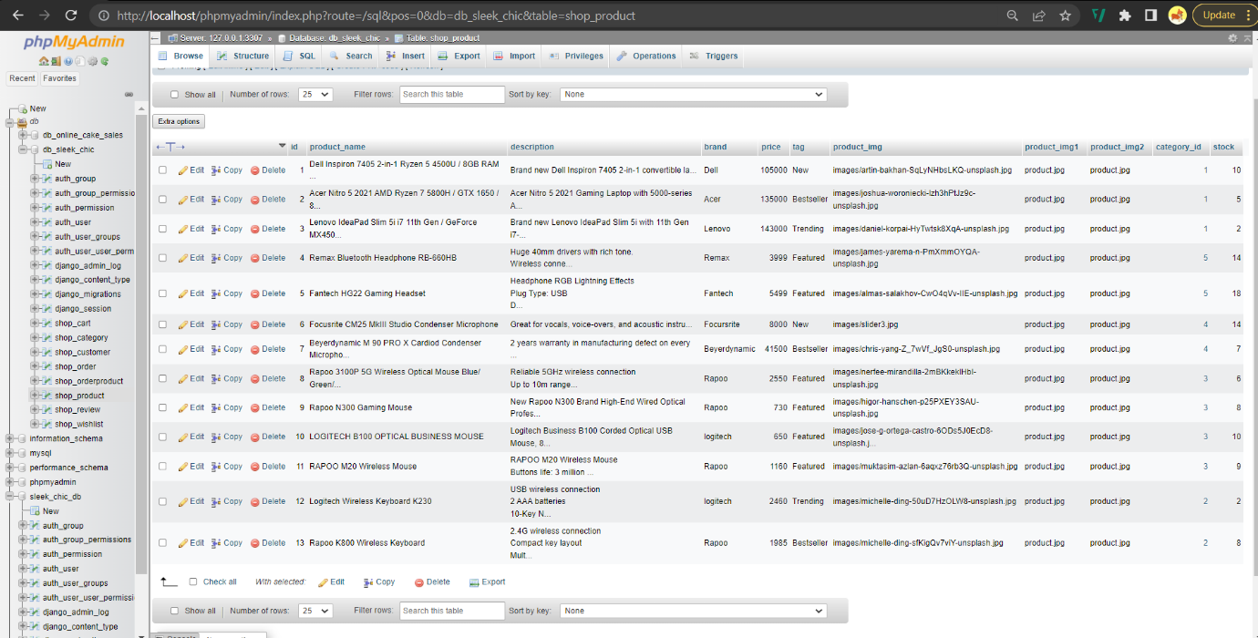

Figure 6 Database

## ADVANTAGES AND DISADVANTAGES OF MYSQL:

The advantages of using MySQL as your database management system is given below:

* Since MySQL is an open source databse server, it minimizes total cost of ownership and suit its settings according to your requirements. Most interesting thing is this database management server is free.
* MySQL supports different platforms like Windows, Linux, Solaris, etc and supports different languages like PHP, Java, python, C++, C, etc. making this databse more portable.
* Seamless connectivity as MySQL server can be connected by various connection mechanisms such as TCP/IP sockets and UNIX sockets.
* The developer community of MySQL releases regular upgrades and patches for MySQL making it assure of 24 x 7 uptime.
* Password of MySQL is stored in encrypted form which brings out MySQL as most secure database. It is also recognized as best secure database server by popular web applications such as Twitter and Facebook.

The disadvantages of using MySQL as your database management system is given below:

* Role, Commit, and stored procedures are not supported by MySQL versions lower than 5.0.
* A extremely high database size is not supported by MySQL as effectively.
* MySQL is susceptible to data corruption and doesn't manage transactions particularly effectively.
* Compared to other databases, MySQL doesn't offer a strong developing and debugging tool.
* There are no SQL check limitations supported by MySQL.

# BACKEND

## INTRODUCTION

A high-level python web framework that provides development of maintainable and secure websites, Django is an open source and free for using as backend to your websites. Django takes care of all hastlefrom your websites and provides you a time to focus on writing your apps. Django seems to work with any client-side framework as it can be used to build almost every kind of websites as well as delivers content in almost any format such as HTML, XML, JSON,etc. This makes Django an versatile open source web framework. It is also secure framework as it avoids common security mistakes by avoiding putting session informations in cookies. Django also protects the system against site scriptinh and cross- site request forgeries. Django framework sets rule for design pattern and design principlemaking its code resuable and maintainable. The below given picture is how Django framework looks like: ("Django introduction - Learn web development | MDN", 2022)

Sleek chic uses django framework as its backend. This project has folder structure in MVT pattern i.e. Model, View, Templates pattern. Since Django is based on MVT pattern, MVT is design pattern used to develop a web application.

Model is responsible for maintaining data as it is logical data structure for entire application. It is generally represented by relational databases such as MySQL, Postgres.

View is represented by HTML, CSS and JavaScripts files. It acts as user interface.

Templates mainly consists static files of required HTML output.

The picture given below shows MVT pattern:

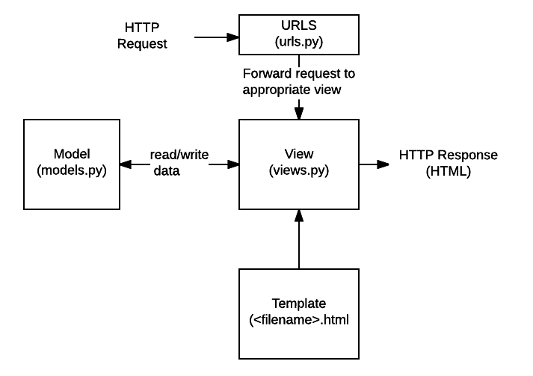

Figure 7 MVT pattern in django

Project structure of MVT pattern in my system is given below:

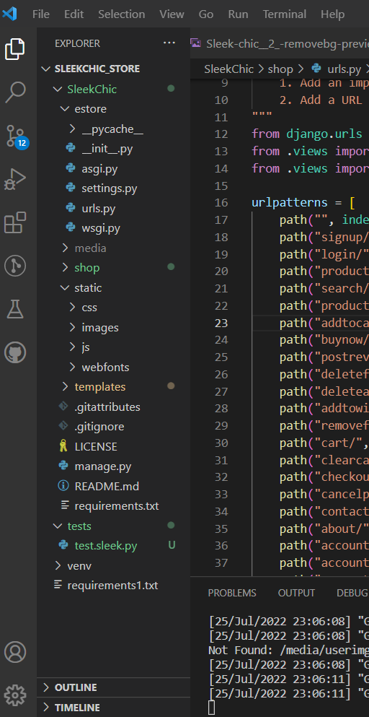

Figure 8 MVT pattern of sleek chic

## ADVANTAGES AND DISADVANTAGES OF DJANGO

The advantage of django used as backend in this project is given below:

* Django Framework has so many features that you don't  need to construct anything but your ownapplication.
* Significant contrasts between the Django Architecture and competing frameworks are offered.
* Due to Django's MTV Architecture's implementation of the notion of loosely linked components  we may work on many components concurrently, that makes the integration much simpler.
* Django has been designed in a way that it can accommodate any hardware upgrades.
* Django Architecture and competing frameworks are offered.
* Due to its loosely linked architecture, Django has the ability to add hardware at any point of the components as long as they can handle the change.

The disadvantage of django used as backend in this project is given below:

* Django makes it a requirement that you cannot use your own file organization.
* The task of defining the URL with regular expressions is not simple.
* It also has a strong sense of opinion, which gives it a monolithic appearance. ("Django Project MVT Structure - GeeksforGeeks", 2022)

## SCREENSHOTS OF BACKEND

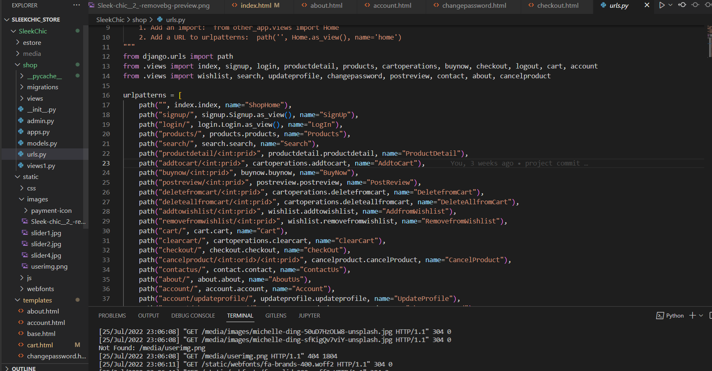

Figure 9 Backend

## ADMIN:

This project uses django admin for administration tasks. Using a web interface, you may add, update, and delete items in your database using the Django admin, a robust built-in tool. Your models may be used by the Django admin application to automatically construct a site area where you can add, view, edit, and remove entries. This may help you save a lot of time when developing and make testing your models and determining whether you have the necessary data simple. Depending on the sort of website, the admin program may also be useful for managing data during production. As a result, registering your models is all that is required to add them to the admin application. ("Django Tutorial Part 4: Django admin site - Learn web development | MDN", 2022)

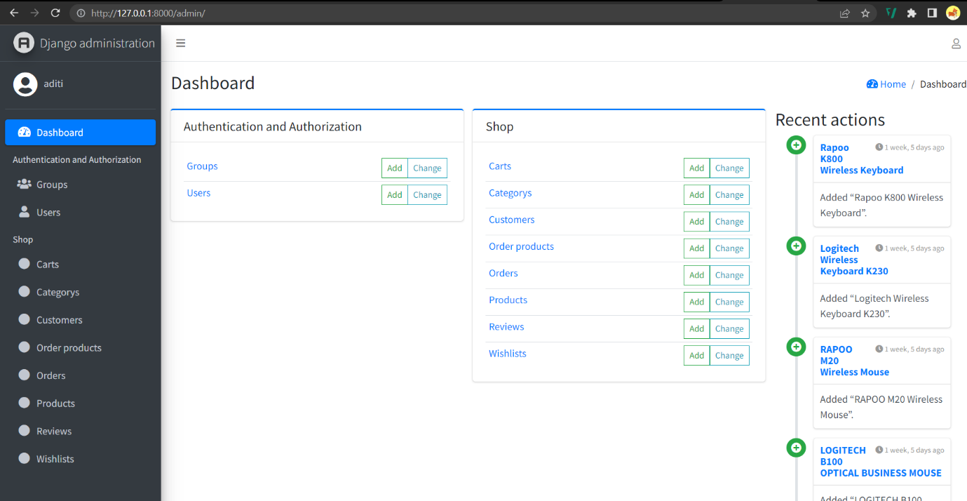

Figure 10 Django admin

## TESTING:

Websites become difficult to manually test as they get bigger. Additional adjustments will be needed to make sure everything continues to operate and no mistakes are introduced when more changes are made. As interactions between components get more complicated, there is not only more to test but a little change in one area might affect other areas as well. Writing automated tests that can be executed with ease and dependability each time a change is made is one technique to address these issues. In the code base's tests directory, Django includes a set of internal tests. All of the Django tests make use of the testing environment that comes with the framework to test applications.

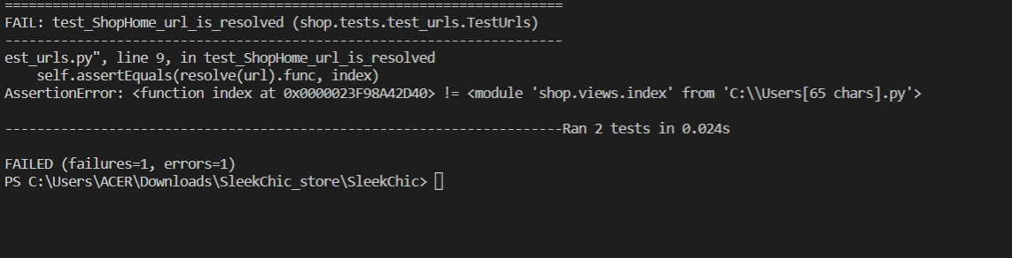

Figure 11 Testing

# PROJECT ISSUES

## ISSUES DURING THE PROJECT DEVELOPMENT

There were lots of issues I faced during development of this project. Everything was meant to be done from scratch. Learning HTML, CSS and Javascipt for frontend took a while. For backend I used Django. The frontend of this project is built by using HTML, CSS and JavaScript whereas for backend I used django.

While doing this projects many diffuclties were faced and the difficulties were swamped and overcomed. The languages were new to me as HTML, CSS, BOOTSTRAP, Js and framework of django was used which was new to me and challengingThere were many things to learn from HTML such as how containers, divs, header, footer and text, text-field, buttons are entered in order to make a website. Where as CSS holds important role in decorating these items mentioned in HTML. The styling, sizing, adjusting, are all part of CSS. While running the project I faced lots of errors and exceptions. Some of the exceptions were not easy to handle. The error message would quote “while handleing this exception, another exception occurred.” While having limited research this types of errors were hard to handle. URL mapping was not easy task as well. I had to give urls for every path which was frustating sometimes. Personally, I feel like django has many add ons. The URL mappings and changes in view.py, models.py, settings.py can be really frustating sometimes. The paths are to be specific and its harder to handle exceptions one after another. But there was much more to learn in django project too such as working with django admin, django database, file uploads, static files handling and many more.

## FUTURE WORK

Though the project has been fully complete, and most of the expectations were met during the building of the project ' SLEEK-CHIC' but still some reworks and rebuilding of the project can be done where making the design of the client side more fluent and fun is essential, working on database and designing can be improved in the upcoming future. Also the scalibility of the website and its database should be bigger in upcoming days.

Many reworks and final touches can be done where it benifits the both user, developers, and admins side of the website 'SLEEK-CHIC'

# CONCLUSION:

In conclusion, this project is developed using Html, Css, and JavaScript (js) as frontend and for backend Django is used. All the database is stored in Django with safety. Sleek chic an e-commerce site where customers get to enjoy many offers on products and instant home delivery.

# REFERENCES:

Knieć, A. (2022). 20 Top Frontend Technologies to Use in 2022. Retrieved 25 July 2022, from <https://www.netguru.com/blog/front-end-technologies>

How Important Is Responsive Design?. (2021). Retrieved 25 July 2022, from <https://devrix.com/tutorial/important-responsive-design/>

MySQL :: MySQL 8.0 Reference Manual :: 1.2.1 What is MySQL?. (2022). Retrieved 25 July 2022, from <https://dev.mysql.com/doc/refman/8.0/en/what-is-mysql.html#:~:text=MySQL%20is%20a%20database%20management%20system.&text=It%20may%20be%20anything%20from,system%20such%20as%20MySQL%20Server>.

MySQL Advantages and Disadvantages - techstrikers.com. (2022). Retrieved 25 July 2022, from <https://www.techstrikers.com/MySQL/advantages-and-disadvantages-of-mysql.php>

Django introduction - Learn web development | MDN. (2022). Retrieved 25 July 2022, from <https://developer.mozilla.org/en-US/docs/Learn/Server-side/Django/Introduction>

Django Project MVT Structure - GeeksforGeeks. (2022). Retrieved 25 July 2022, from [https://www.geeksforgeeks.org/django-project-mvt-structure/#:~:text=Django%20is%20based%20on%20MVT,for%20developing%20a%20web%20application.&text=View%3A%20The%20View%20is%20the,CSS%2FJavascript%20and%20Jinja%20files.](https://www.geeksforgeeks.org/django-project-mvt-structure/%23:~:text=Django%20is%20based%20on%20MVT,for%20developing%20a%20web%20application.&text=View%3A%20The%20View%20is%20the,CSS%2FJavascript%20and%20Jinja%20files.)  
  
Django Tutorial Part 4: Django admin site - Learn web development | MDN. (2022). Retrieved 6 August 2022, from <https://developer.mozilla.org/en-US/docs/Learn/Server-side/Django/Admin_site>